Assignment #5

Josh Jackson - 250722551

Question 1

Flow Chart: 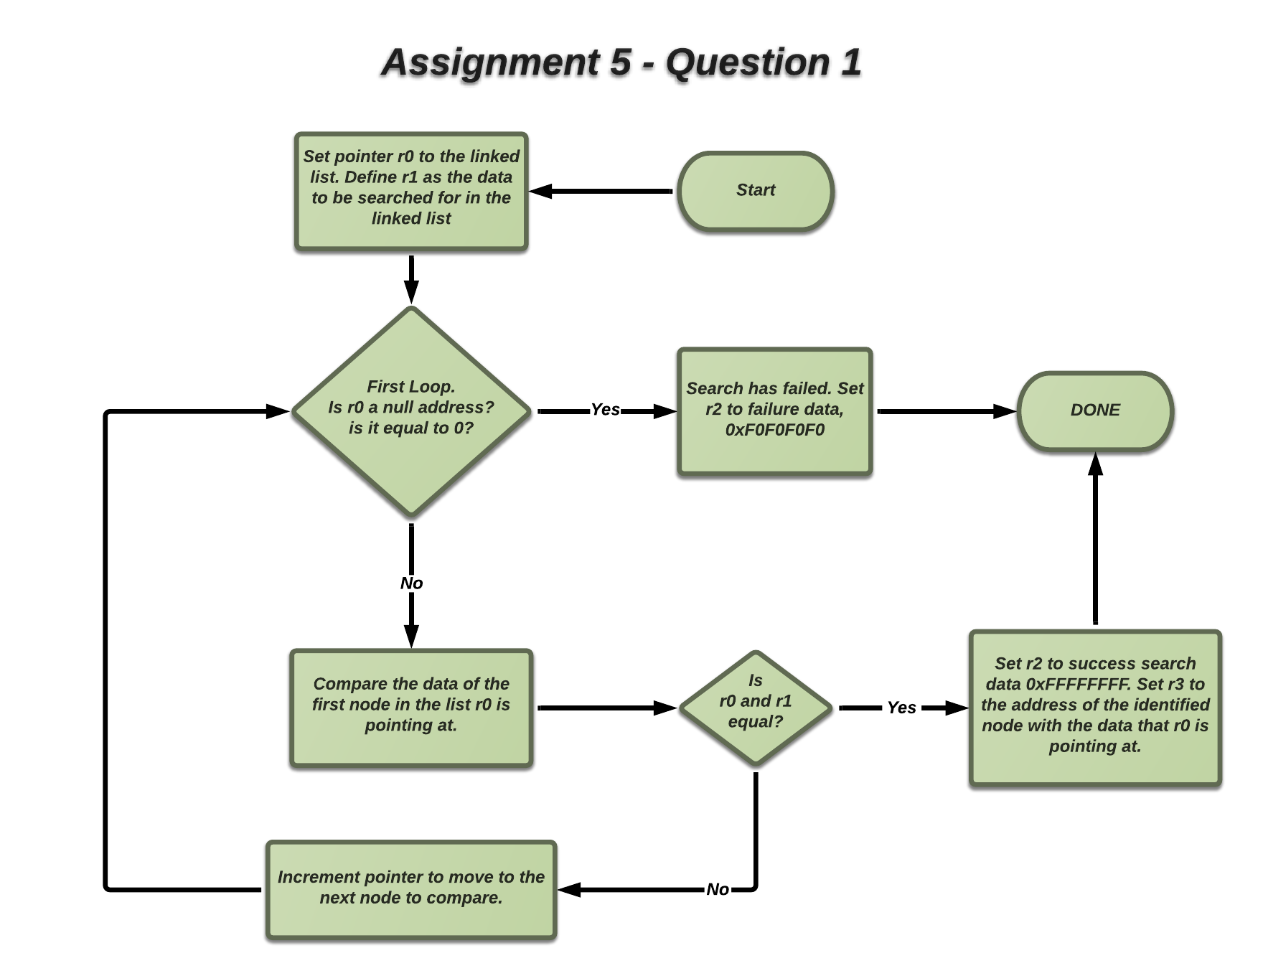

Code: 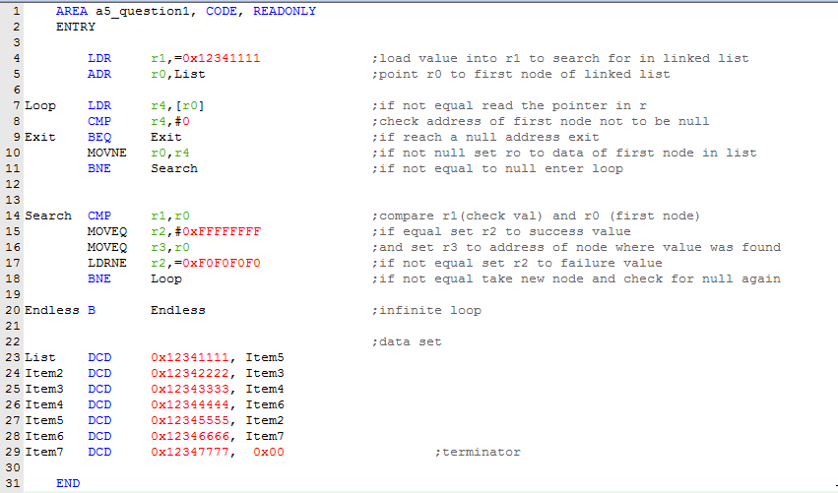

Question 2

Flow Chart: 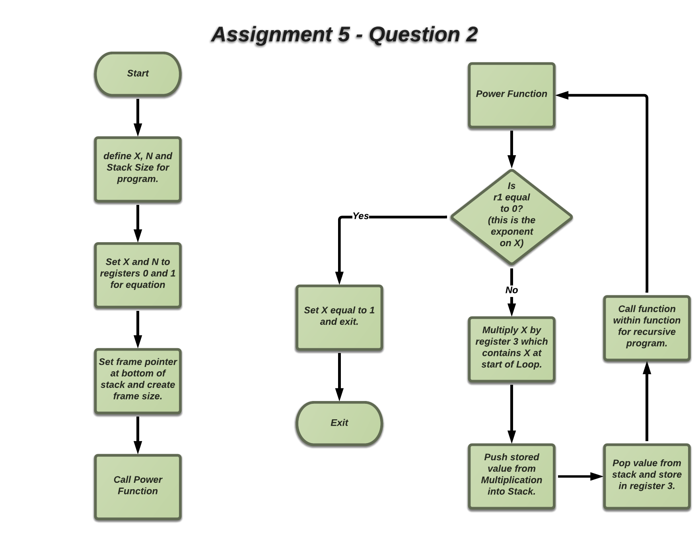

Code:

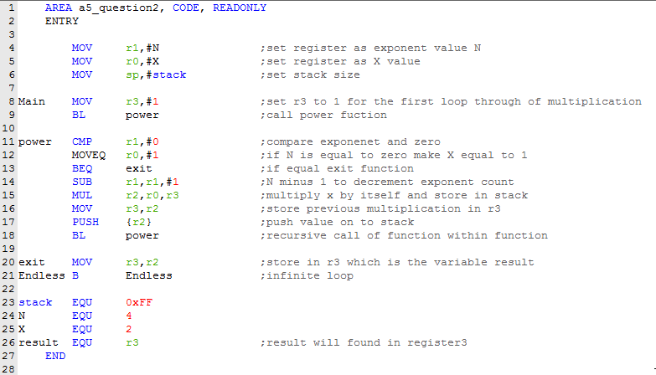

How many stack frames are needed to calculate *xn*, when n = 0, 1, 2, 3, 4, 5, 6, 7, 8, 9, 10, 11, and 12?

In order to calculate *xn you would need a stack frame for every exponent after every multiplication. For example, 0 would need 1 frame, 1 would need 2, 3 would need 4, and so on.*